dFaculty of Computer Technology and Cybersecurity
Department of Computer Engineering
ARCHITECTURE AND ORGANIZATION OF COMPUTER SYSTEMS
LABORATORY WORK - 6

Date: 08.11.2026
Full Name: Daniil Kalts
Group: IT2-2404SE

PROGRESS OF WORK
1) Start the Microchip Studio.
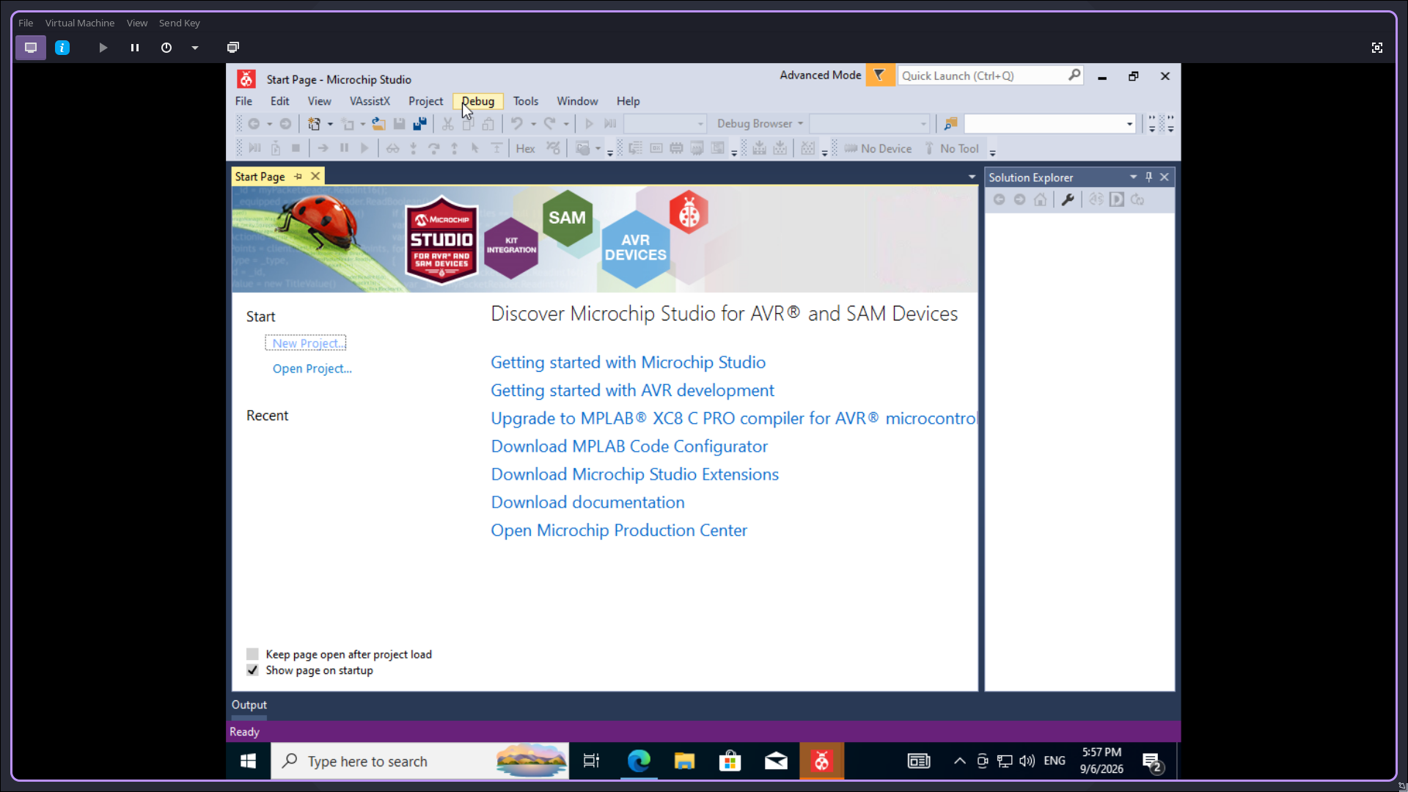

2) Create a new GCC C Executable project.
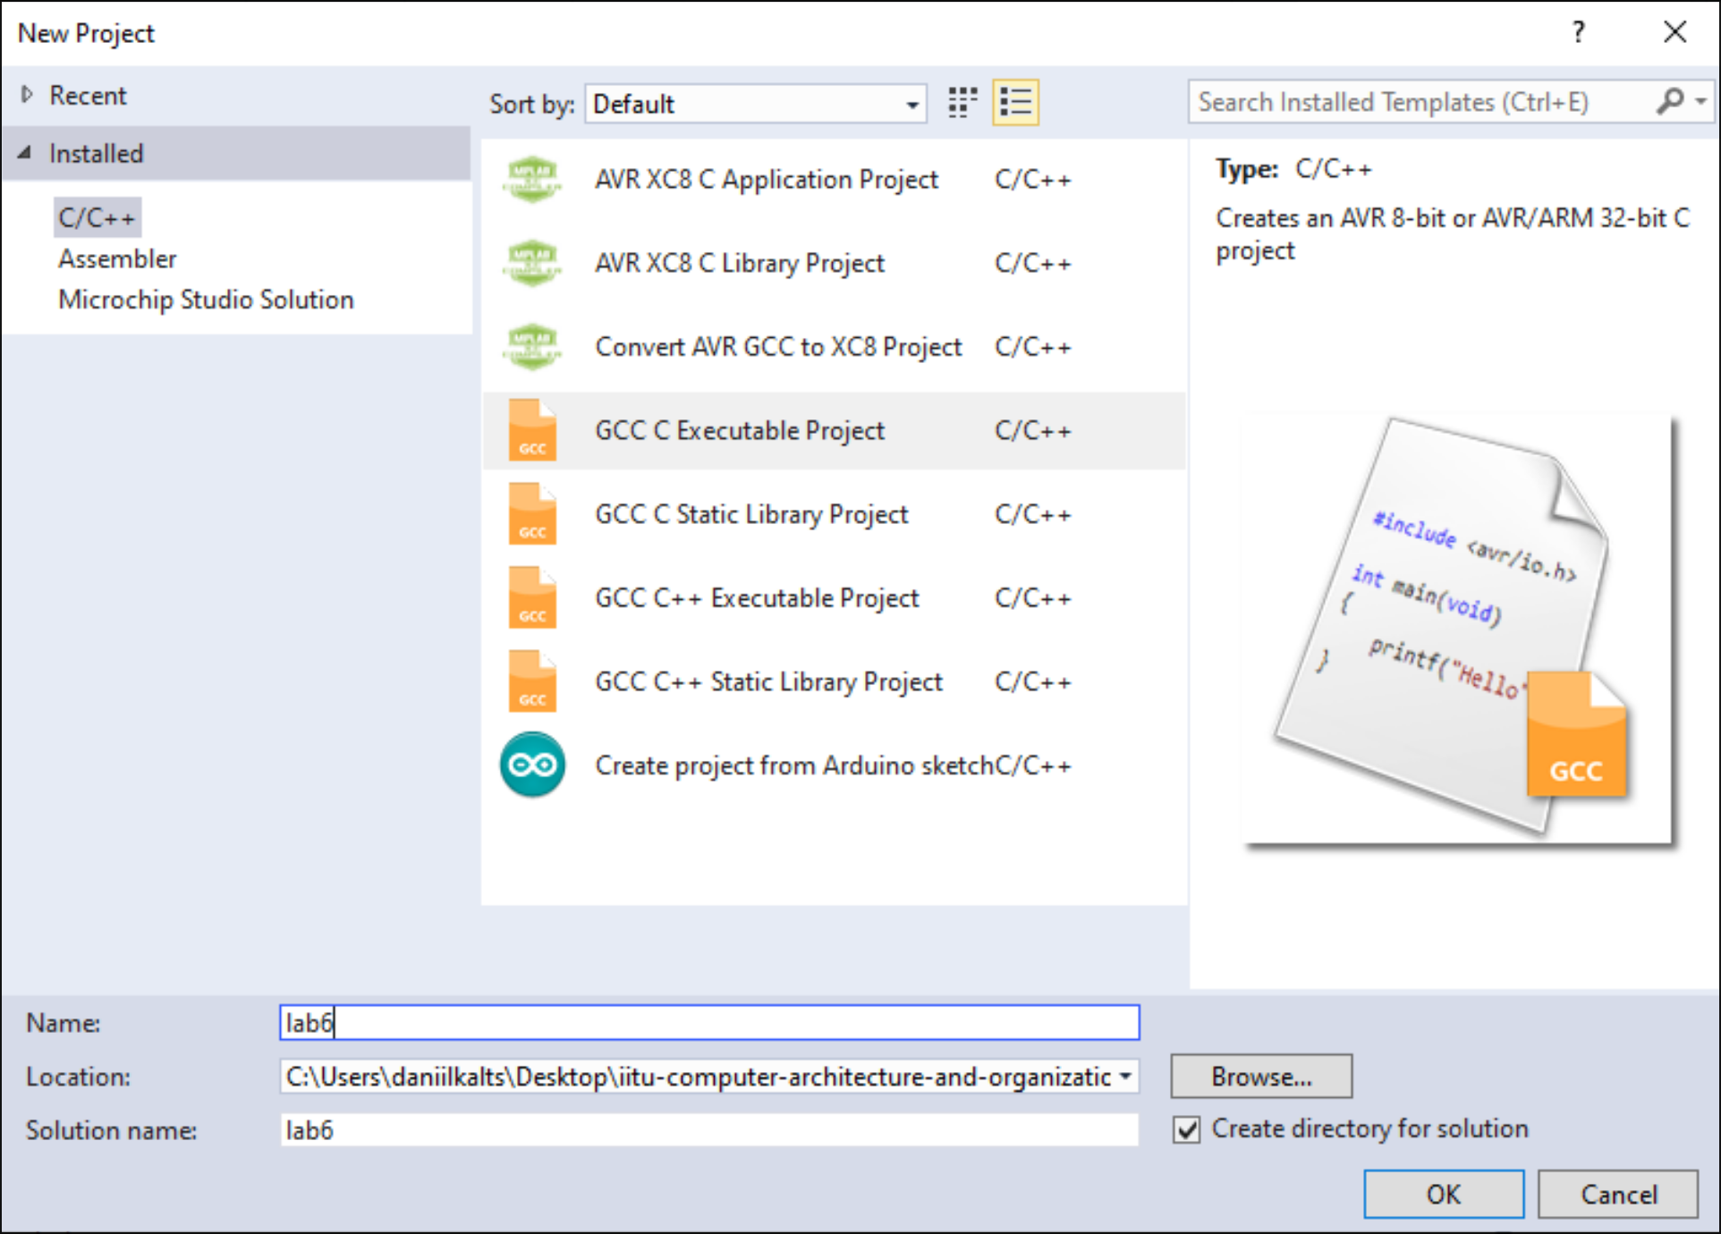
3) Select the device (in this work — ATmega32).
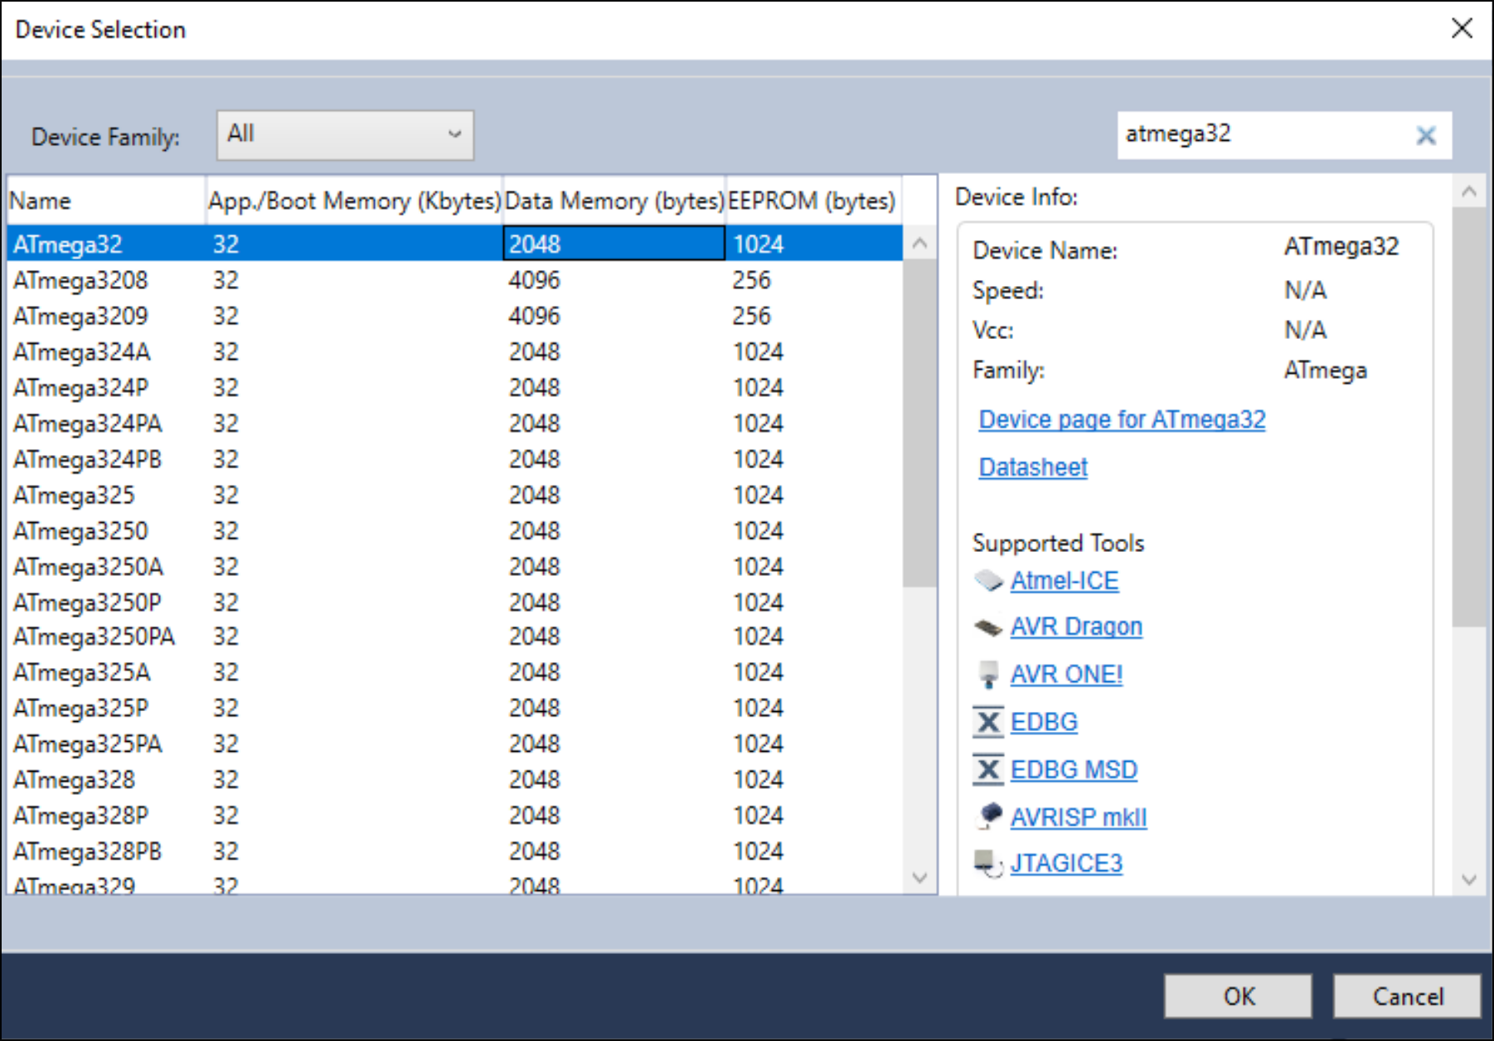

4) Next, program the microcontroller.
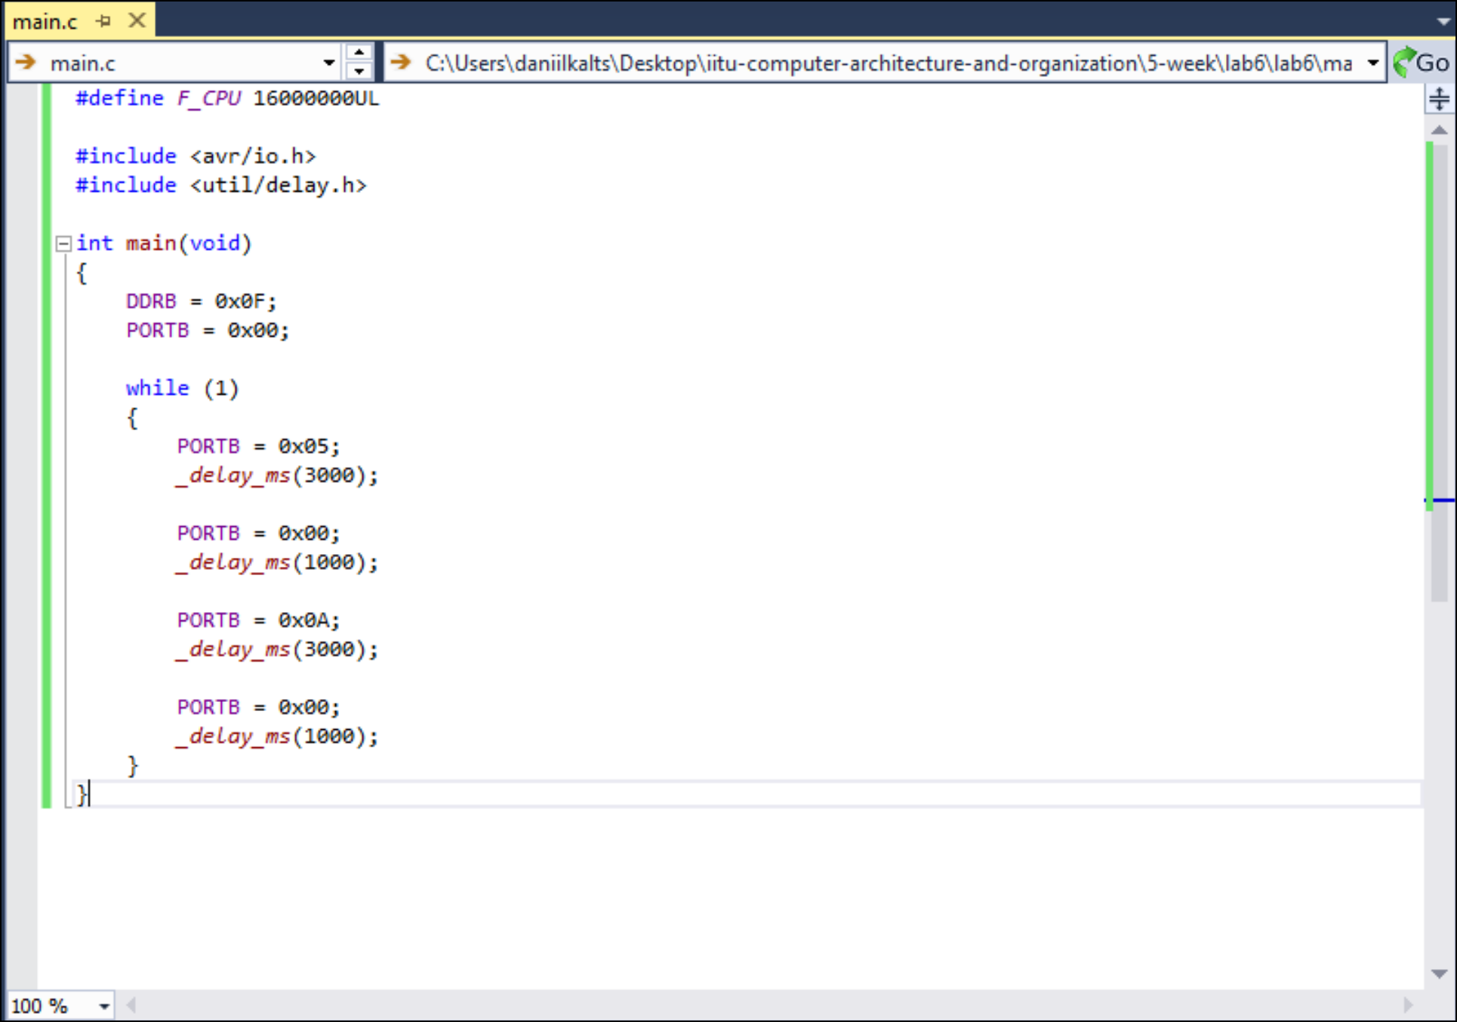
5. Compile the project and obtain the .hex file.
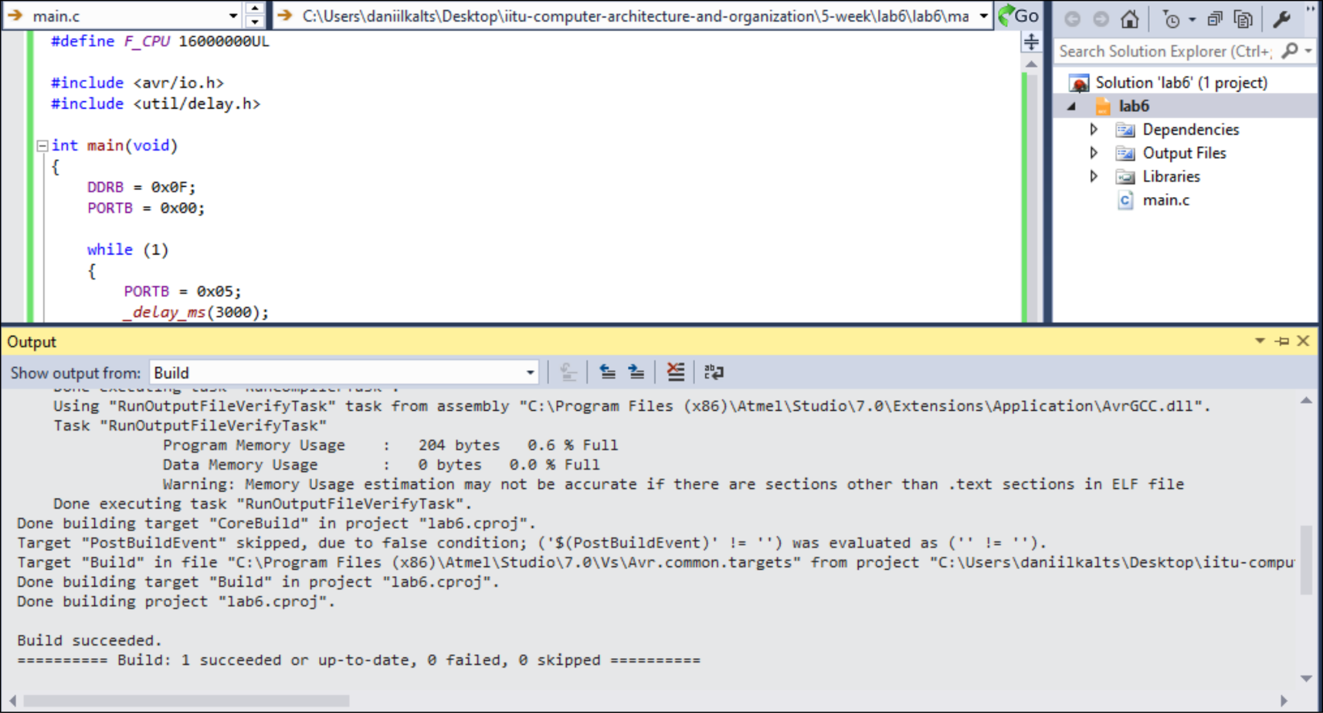

6. Add the ATmega32, two DC motors, an L293D motor driver, a 16 MHz crystal, two 22 pF capacitors, a 10 kΩ resistor, 5 V and 12 V power terminals, and GND to the schematic. Connect PB0–PB3 to the L293D’s IN1–IN4 pins, and connect the motors to its output pins.
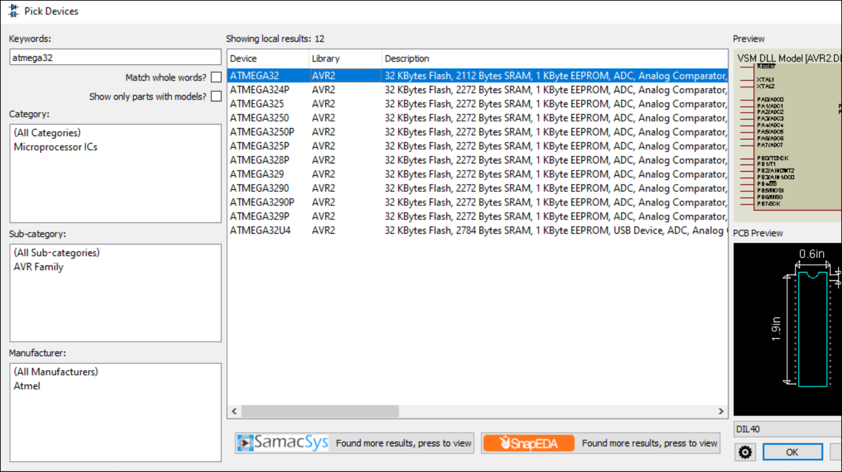
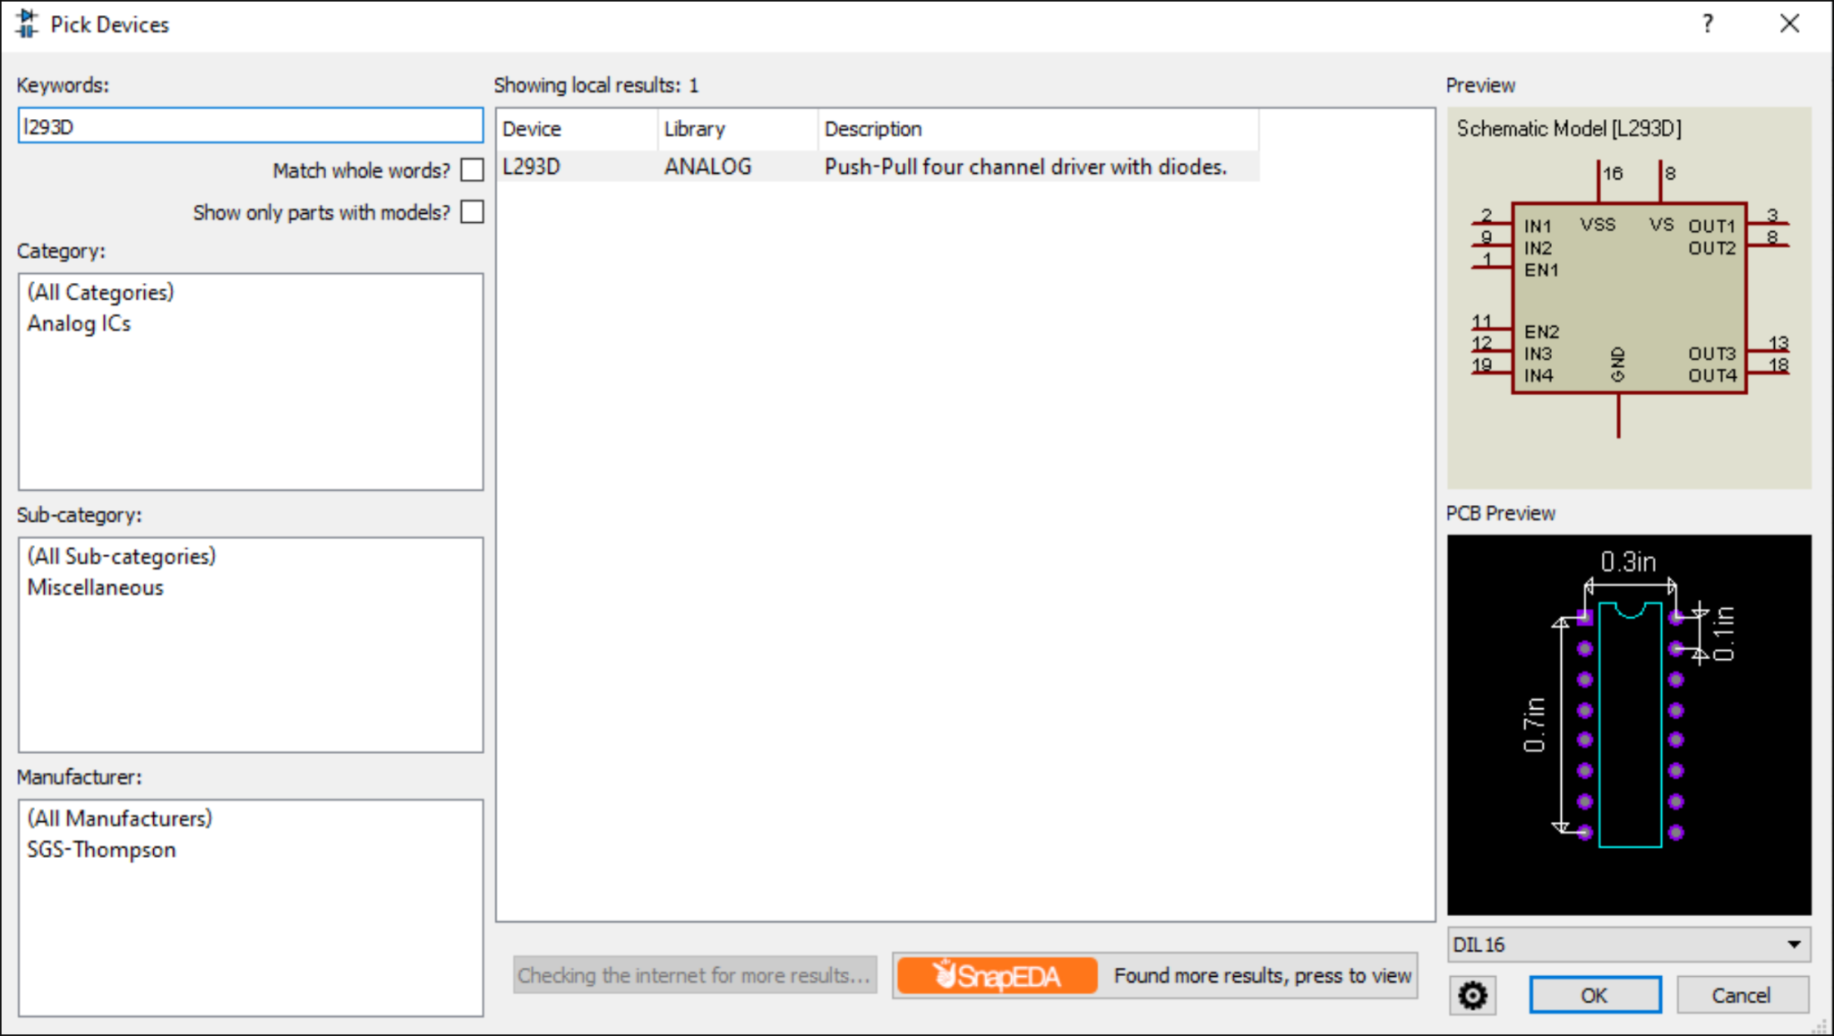

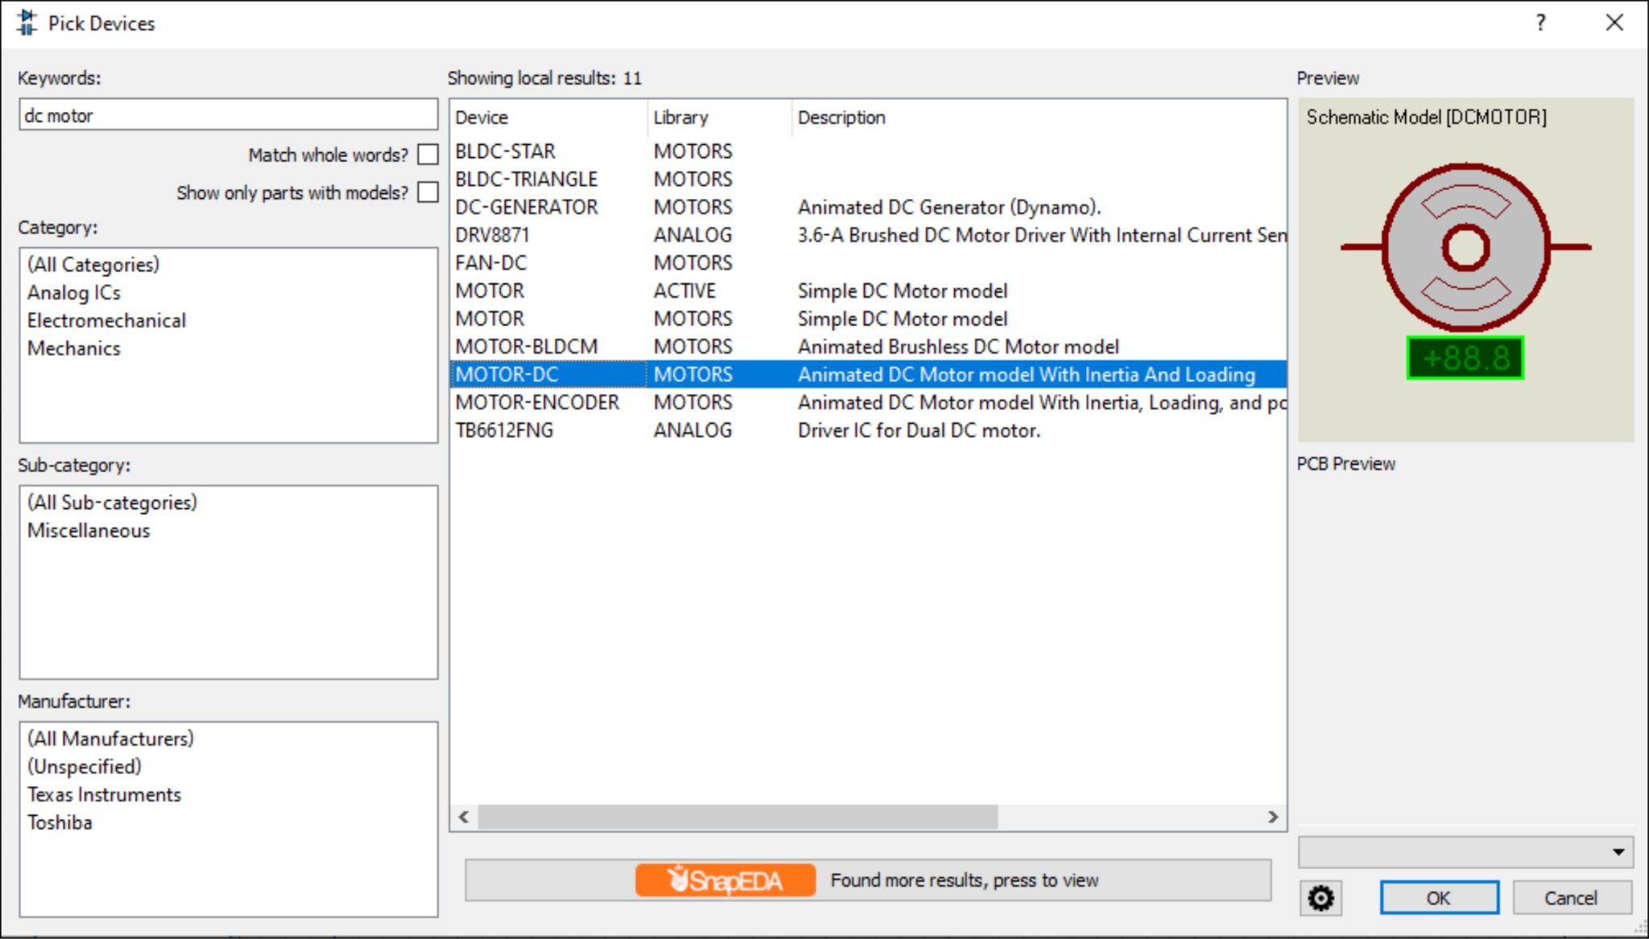
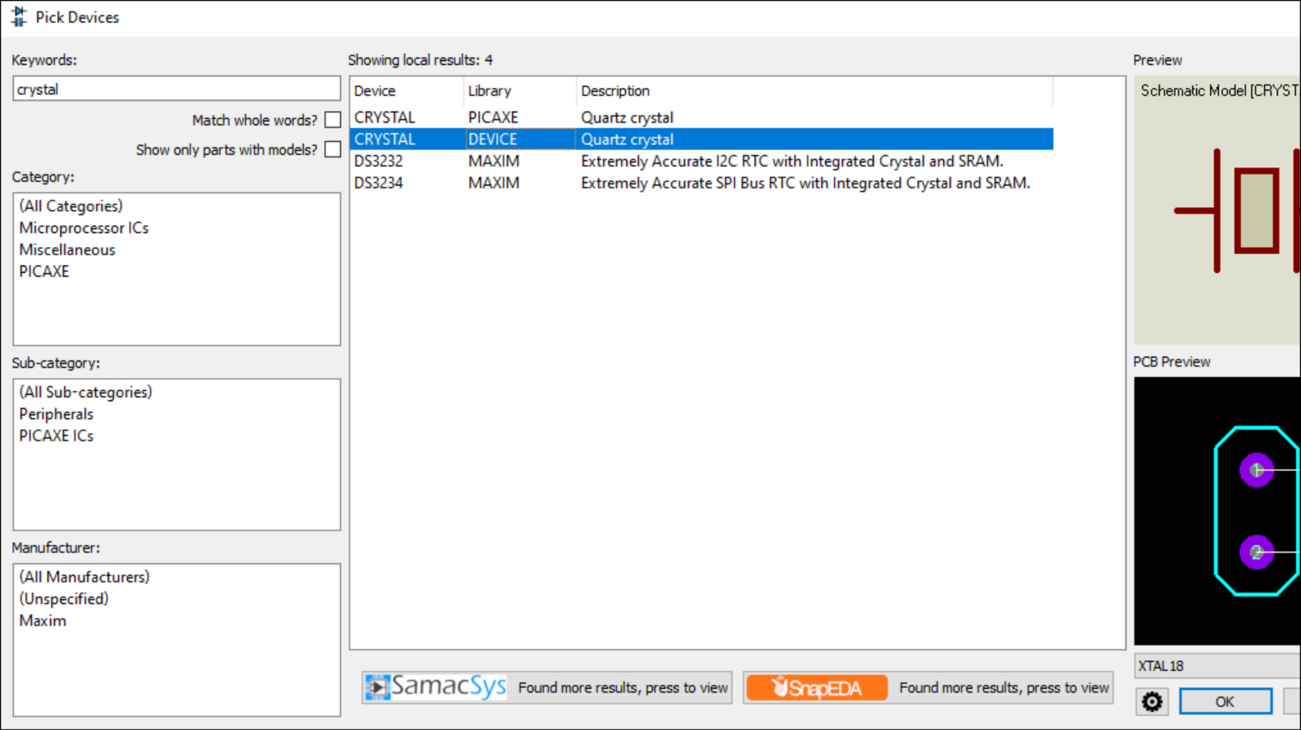
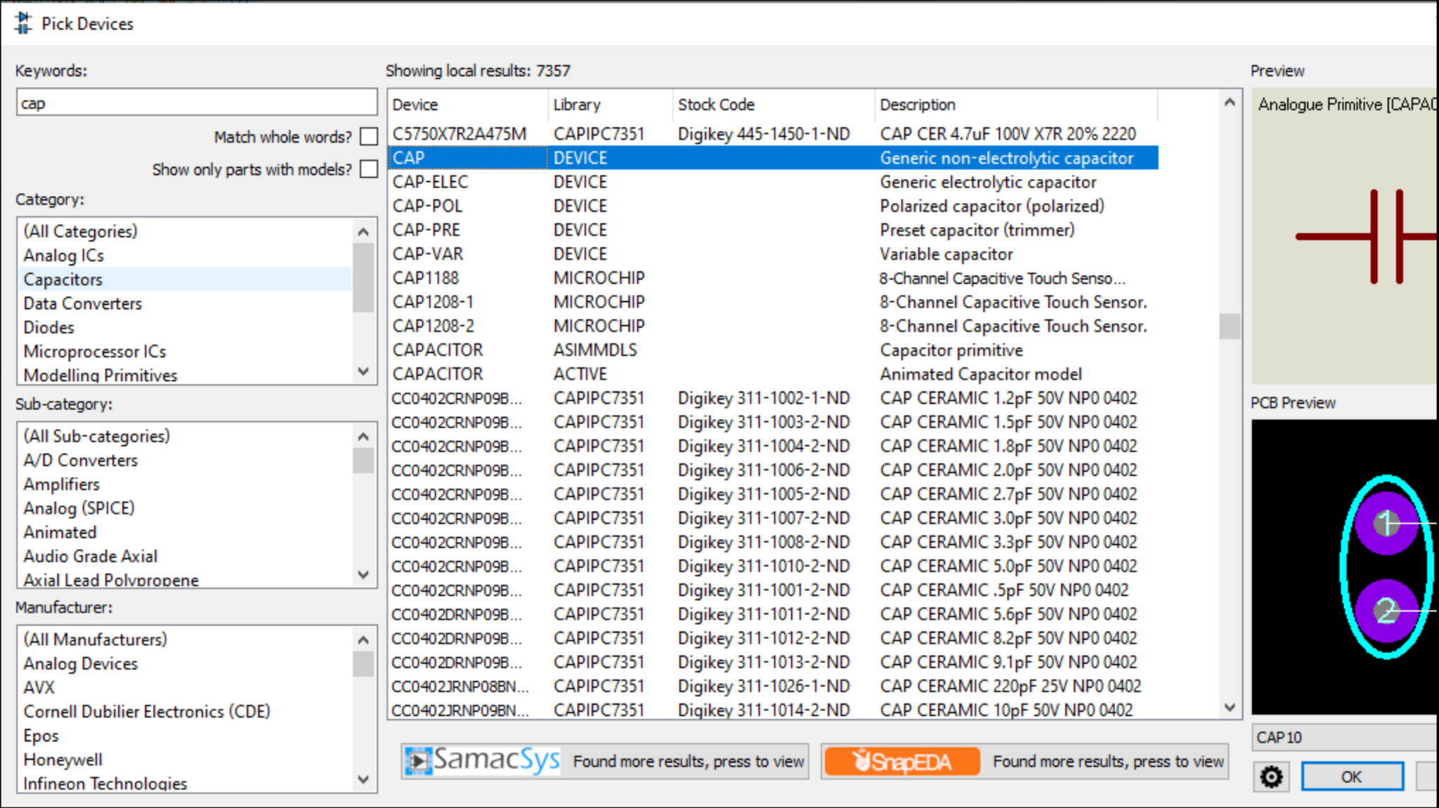
7. Load the compiled .hex file into the microcontroller's properties (Program File) and
configure the component
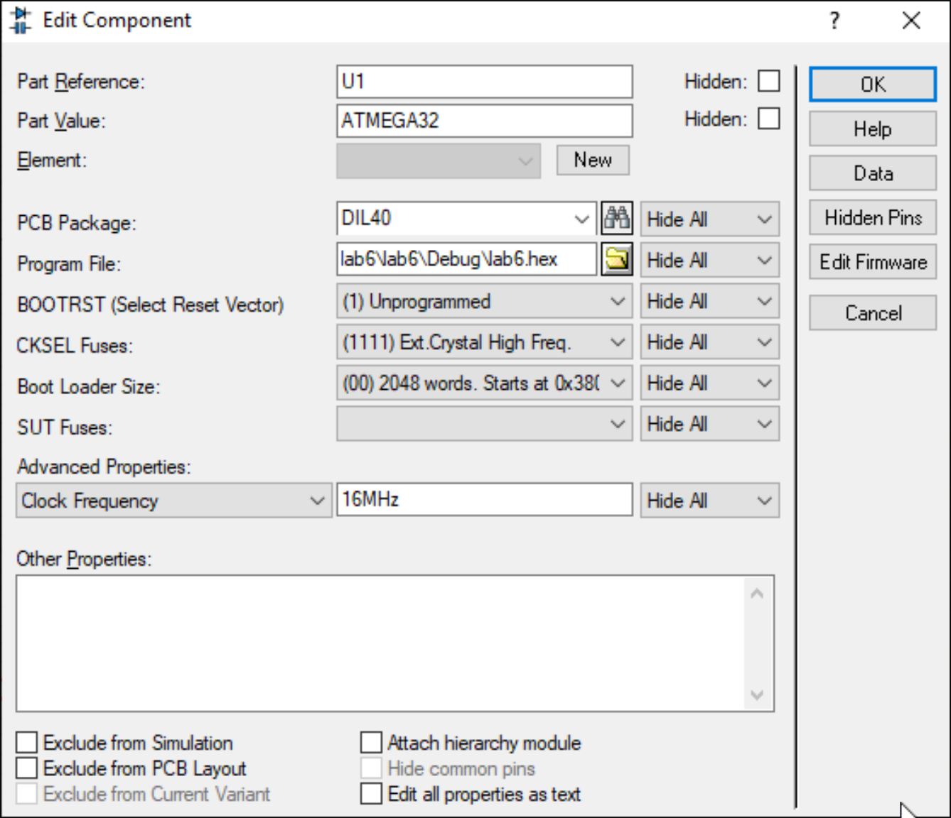
8. Run the simulation and verify that both DC motors rotate clockwise and anticlockwise, then stop, according to the program.

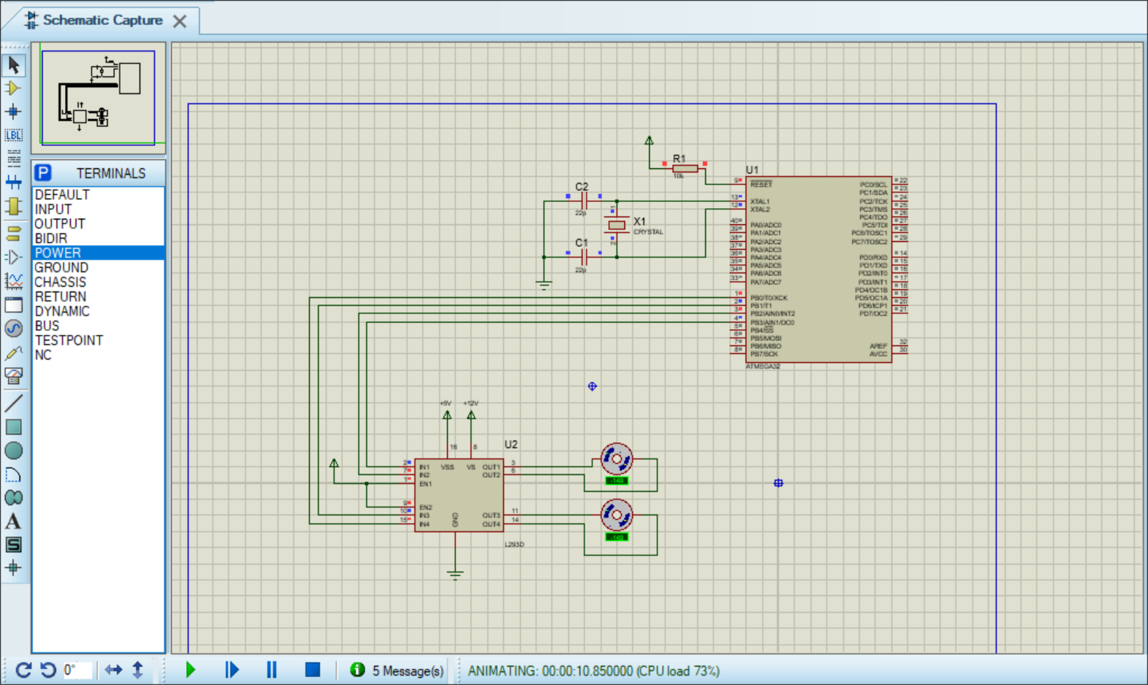

Conclusion:
In this laboratory work, I programmed the ATmega32 to control two DC motors through the L293D. The motors changed direction and stopped according to the program.

